Array Tomography

Kristina D. Micheva and Stephen J Smith
Stanford University School of Medicine

1. Tissue fixation.
Note: Below follows the protocol that we use for chemical fixation, but tissue prepared in a number of different ways can also be used – for example, fixed by perfusion. It should be dissected into small pieces of < 1 mm in at least one dimension. If you already have your tissue fixed, continue from section 2.

Required materials and equipment:

Halothane (Sigma #B4388)
Paraformaldehyde (16%, EM grade; Electron Microscopy Sciences #15710)
PBS (Sigma #P3813)
Sucrose
Guillotine: for adult rats
or
Sharp scissors: for young rats and mice
Dissection instruments: handling forceps, small scissors, bone rongeur, forceps #5; small spatula; scalpel, glass pipette (tip broken off) with a bulb to transfer the tissue pieces.
Red biohazard bag
Petri dishes (35 mm)
Glass scintillation vials (20 ml)
Optional: PELCO 3451 laboratory microwave system with a ColdSpot set at 12^{ο}C; Ted Pella: speeds up sample preparation. In the protocols below two options are provided: MW - microwave processing or BT - bench top processing.
To prepare:

PBS: Dissolve 1 packet in 500 ml to prepare 0.02M PBS.

Fixative (prepare the same day, keep at room temperature): 4% paraformaldehyde, 2.5% sucrose in 0.01M PBS
For 4 ml: 1 ml PF (16%)
2 ml PBS (0.02M)
1 ml H2O
0.1 g sucrose

Procedure (for rodent brain):

►Anesthetize the animal using halothane.
►Remove head using the guillotine for adult rats or sharp scissors for young rats and mice.
►Quickly remove the brain out of the skull. Dissect out the region of interest and cut into small pieces (< 1 mm in at least 1 dimension) in cold PBS.
►Quickly transfer to a scintillation vial with fixative solution (room temperature).
Note: For MW, use approximately 1ml of fixative per vial, or just enough to cover the tissue; excessive liquid volume will cause overheating in the microwave.

MW: ►Microwave using a cycle of 1 min on – 1 min off – 1 min on at 100 – 150W. Note: After this and each following cycle feel the glass vial to check for overheating. If solutions are getting too warm (>37°C), decrease the amount of liquid added.
►Microwave using a cycle of 20 s on – 20 s off – 20 s on at 350-400W: repeat 3 times.
►Leave at RT for about 1 h.

BT: ► Fix @ room temperature for up to 3h or overnight at 4ºC.

2. Dehydration and embedding.

Required materials and equipment:

PBS (Sigma #P3813)
Sucrose
Glycine
Ethanol (200 proof)
LR White resin (medium grade, SPI supplies #2646)
Gelatin capsules (Size 00, EMS#07010)
Capsule holder (pictured in the Figure)
Oven (set at 51 – 53°C)
Optional: PELCO 3451 laboratory microwave system with a ColdSpot set at 12^{ο}C; Ted Pella: speeds up sample preparation. In the protocols below two options are provided: MW - microwave processing or BT - bench top processing.

To prepare:

PBS: Dissolve 1 packet in 500 ml to prepare 0.02M PBS.

Wash buffer: 3.5% sucrose and 50 mM glycine in 0.01M PBS (can be prepared in advance and stored at 4°C for up to 1 month; discard if appears cloudy):
To make 50 ml: 25 ml PBS (0.02M)
25 ml H2O
1.75 g sucrose
187.5 mg glycine
Ethanol dilutions (keep at 4°C):
50% ethanol
70% ethanol
95% ethanol

Procedure:

►Wash in wash buffer (cold from fridge) and keep the samples at 4°C. 2-3 times for up to 30 min. Note: At this point the sample can be left overnight at 4°C, although for very sensitive antigens it may be better to continue with the following dehydration.

MW: ►50% ethanol (4°C) – 30 s @ 350W. Note: For MW, use approximately 1ml of fixative per vial, or just enough to cover the tissue; excessive liquid volume will cause overheating.
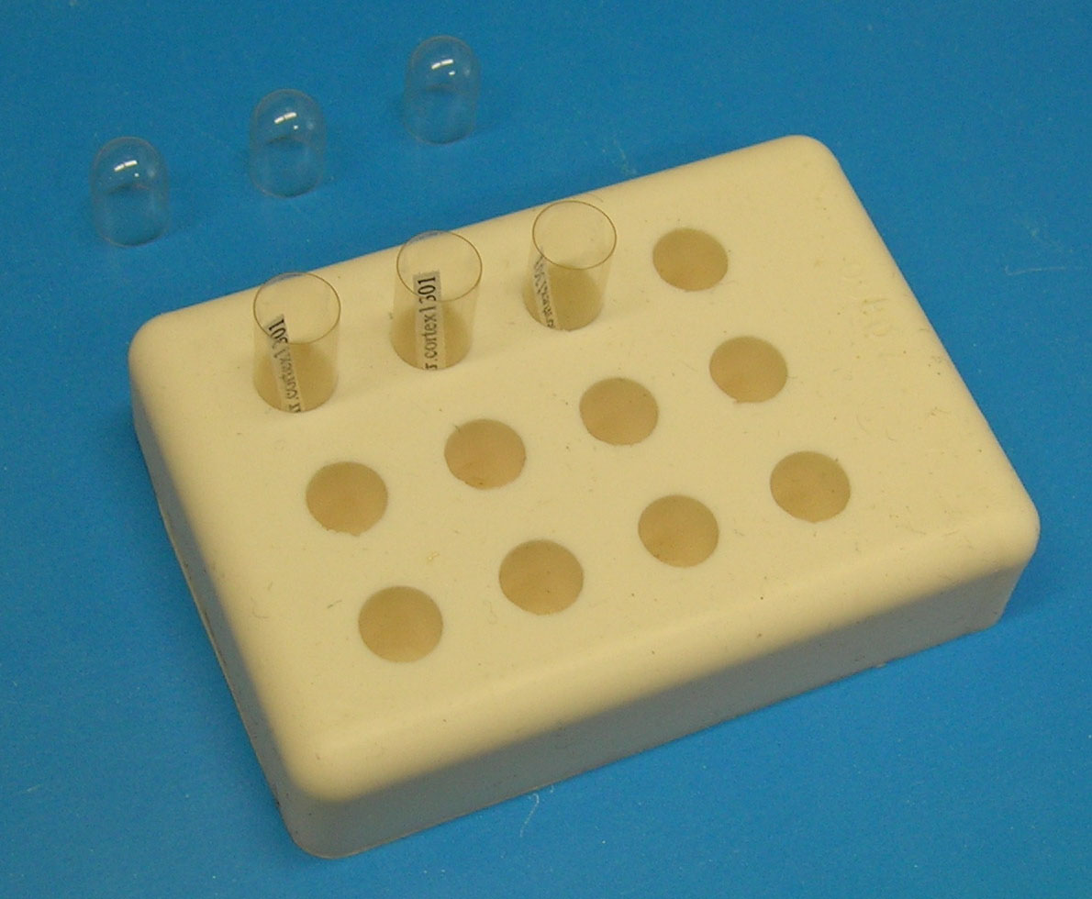
►70% ethanol (4°C) – 30 s @ 350W
Stop here if processing samples with GFP (see below).
►95% ethanol (4°C) – 30 s @ 350W
►100% ethanol (4°C) – 30 s @ 350W
►100% ethanol and LRWhite resin (1:1 mixture) - 30 s @ 350 W.
►LRWhite (100%) - 30s @ 350W
►LRWhite (100%) - 30s @ 350W
For preservation of GFP fluorescence omit the 95% and 100% ethanol. Instead, repeat 70% ethanol one more time and then place samples into a mixture of 70% ethanol (1 part) and LRWhite (3 parts) - 30 s @ 350 W. Then do 100% LRWhite 2 times for 30 s @ 350W.

BT: ►Do each of the above steps for 5 min.

►Change with new LRWhite and leave overnight in fridge (~3 h is sufficient).
►Next day, put tissue at the bottom of gelatin capsules (paper labels can also be added inside the capsule) – see Figure, and fill to the rim with LRWhite.
►Close the capsules well. Note: Oxygen inhibits LRWhite polymerization and that is why gelatin capsules, which completely exclude air, are used. The little bubble of air that will remain at the top of the capsule will not interfere with the polymerization.

►Put capsules into oven at 51ºC - 53ºC for approximately 24 h. Note: If the oven temperature falls even 1º below 50ºC, the resin may not polymerize. It is better to set the oven temperature just above 50ºC (51-53ºC) to ensure consistent polymerization.
3. Preparation of the arrays:

Required materials and equipment:

Glass slides: e.g. precleaned Gold Seal Rite-On micro slides
Or for better resolution: Coverslips, e.g. VWR Micro Cover Glasses, 22x60 mm, N0.1.5
Gelatin (300 Bloom)
Chromium potassium sulphate
Jumbo Histo Diamond Knife (Diatome)
Cryotrim 45 Diamond Knife (Diatome) - optional
Ultramicrotome
Weldwood Contact Cement
Xylene
Thin paint brush
Slide warmer (Set at 60 – 65°C)

To prepare:

Subbed slides or coverslips:
What you need:
1. Slides or coverslips (must be clean and dry)
2. Staining racks to hold the slides (glass or metal)
3. Staining tank, just big enough to hold the staining rack
4. Subbing solution. Dissolve 1.5 g gelatin in 290 ml distilled water by heating to <60ºC. Dissolve 0.15 g chromium potassium sulphate (chrome alum; CrK(SO4)2.12H2O) in 10 ml water. Combine the two solutions, filter and pour into the staining tank. Use fresh.
What to do:
1. Put the clean slides in the staining rack.
2. Immerse in the subbing solution for 30 to 60 seconds, with occasional gentle agitation.
3. Lift out and drain off excess liquid, then leave the rack of slides in a dust-free place until dry.
The dry subbed slides are stored in boxes until they are needed.
Glue: dilute contact cement with xylene (1:1 or 1:2 until easily applicable with a paintbrush).

Procedure:

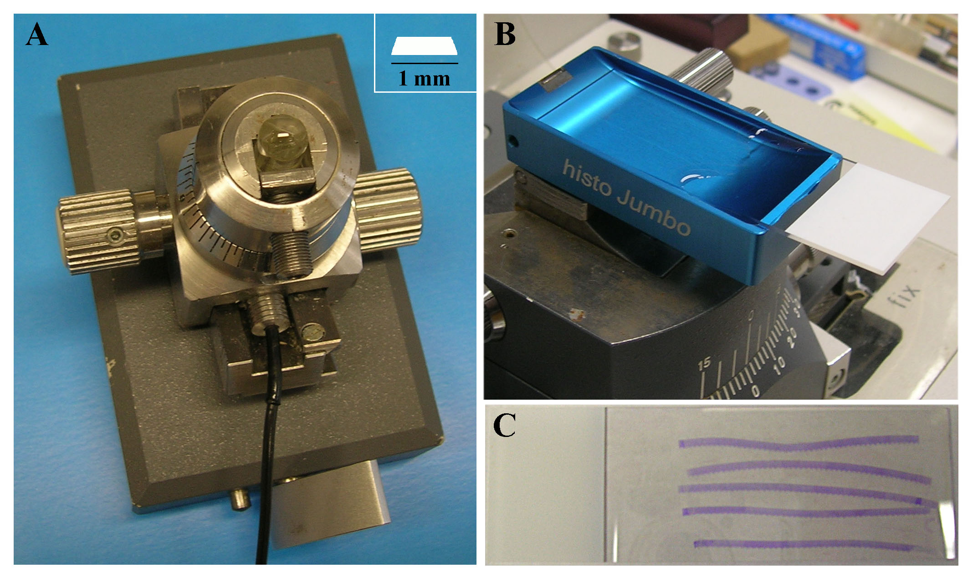
►Trim the block around the tissue. A smaller blockface (1mm or less width) with the width of the trapezoid greater than its height works best - see Figure A.
►Cut semithin sections until you reach the tissue. Trim the block again at this point, to ensure that the blockface is not too big and the leading and trailing edge of the blockface are parallel. The cryotrim 45 diamond knife is very good for this purpose.
►Using a paint brush, apply the diluted glue to the leading and trailing sides of the block pyramid.
►Insert a subbed slide or coverslip into the knife boat of the Jumbo Histo diamond knife – see Figure B. Mounting the sections on coverslips will result in better resolution of the immmunofluorescence.
►After the glue has dried (~ 2 min), start cutting ribbons of serial sections (60–200 nm) with the diamond knife. In general, thinner sections stick better to the glass.
►When the desired length of the ribbon is achieved, carefully detach it from the knife edge using an eyelash and then, again with the eyelash, gently push the ribbon towards the slide, so that the edge of the ribbon touches the slide at the interface of the slide and the water. The edge of the ribbon will then stick to the glass slide. Using a syringe, slowly lower the water level in the knife boat until the entire ribbon sticks to the glass. Take out the slide.
►After the water has dried out, the glass slide can be inserted again into the knife boat in order to mount another ribbon – see Figure C (methylene blue stained array of serial sections – the dye was used only for the purpose of this figure, the sections should not be stained with methylene blue before immunostaining).
►The glass slide with the mounted section ribbons (dried out) is placed on the slide warmer (~ 65°C) for 30 min. The slides can be stored at room temperature for at least 3 months.
4. Immunostaining:

Required materials:

Diamond pen
PAP pen (ImmmEdge Pen, Vector Laboratories)
Tris Buffered Saline tablets (Sigma #T5030)
Glycine
Bovine serum albumin or other appropriate blocking agents
Primary and secondary antibodies
Plastic transfer pipets
Mounting medium: SlowFade Gold antifade reagent with DAPI (Invitrogen)
Coverslips (24x50 mm, e.g. Gold Seal Cover Glass) if sections are mounted on glass slides,
Or Glass Slides, if sections are mounted on coverslips.

To prepare:

Tris buffer: dissolve 1 tablet in 15 ml H2O.
50 mM glycine in Tris: 4 mg glycine in 1 ml of Tris.
Blocking Solution: 0.05% Tween and 0.1% BSA in Tris: First prepare 1% Tween stock (10 μl Tween in 1 ml of H2O). Then add 50 μl of the 1% Tween stock and 10 μl of 10% BSA solution to 0.94 ml Tris buffer.
Primary antibodies: Higher concentration than used for immunofluorescence on Vibratome or cryostat sections, usually 1:50 to 1:100 from a stock of 1mg/ml, diluted in Blocking Solution
Secondary antibodies: (FITC, Rhodamine Red-X, Cy5) 1:50 (from a stock of 0.75 mg/ml); Alexa 1:150 (from a stock of 2 mg/ml) in Blocking Solution
Note: Approximately 150 μl of solutions will be enough for a ribbon of about half the slide length. Spin down all antibody solutions at 13,000 rpm for 2 min.

Procedure:
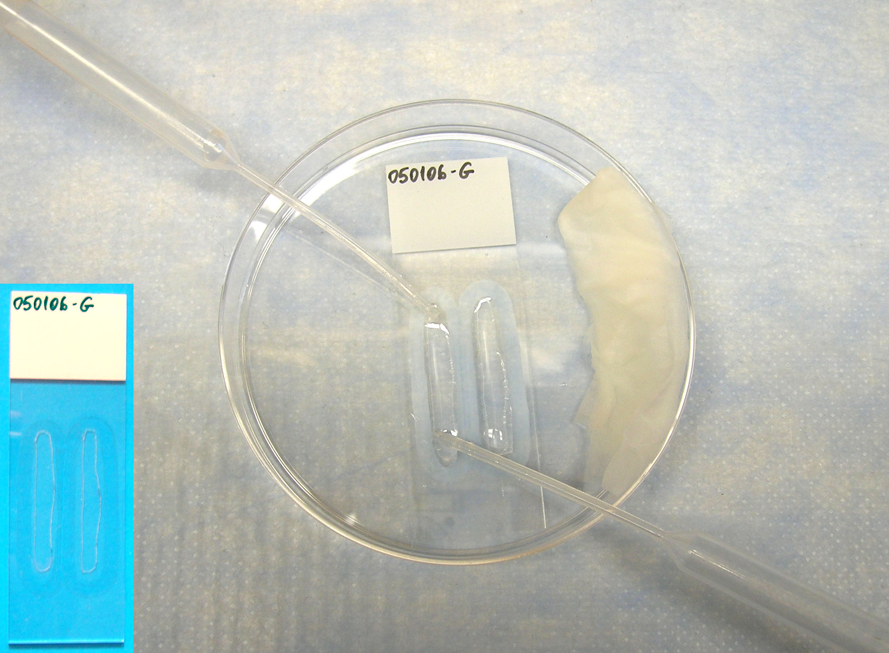
►Mark the position of the sections on the bottom side of the slide using a diamond pen (or with marker if using coverslips) – see Figure insert. Note: This is very important, because it will be hard to find the sections once they are mounted if their exact position is not known.
►Encircle the sections with a PAP pen.
►Put the slides in a container that can be closed, e.g. a Petri dish, and add some wet KimWipes on the side to prevent evaporation of solutions. Keep closed during incubation times.
►Glycine in Tris for ~ 5 min, room temperature.
Note: After the staining begins, it is important not to let the sections dry at any point!
►Blocking solution for ~ 5 min.
►Primary antibody (~1:50 – 1:100) in Blocking Solution for 2 hours at room temperature or overnight at 4ºC. Spin down the antibody solution at 13,000 rpm for 2 min before applying to sections. Note: Some antibodies require longer periods of incubation to achieve complete staining (4h at RT or overnight at 4ºC; e.g. synapsin from Chemicon); others work better with the 2h incubation (e.g. GAD from Chemicon, PSD95 from NeuroMabs)
►Wash several times with Tris. Washing of the sections is done in several periods (3-4 periods of about 10-15 s) of continuous flow of buffer, by adding buffer with a plastic transfer pipet on one side of the sections and removing buffer with another pipet on the opposite side of the sections – see Figure.
►Secondary antibody (e.g. Alexa, 1:150) in blocking solution for 30 min at room temperature. Spin down the antibody solution at 13,000 rpm for 2 min before applying to sections. Keep in the dark.
►Wash with Tris several times.
►Wash with distilled water: wash the sections once, and then wash the whole slide. Note: At this point it is very easy for the sections to dry out, so be careful to always leave some water behind.
►Mount with SlowFade Gold antifade reagent with DAPI (Invitrogen). The DAPI stain helps find the sections and focus.
Note: It is better to image the same day or the next day after the staining. For some antigens, the staining may be very weak and not visible by eye. Use a high mag objective (e.g. 63x or 100x) and longer exposures on a camera (up to several seconds) if necessary.

5. Antibody elution.

Required materials and equipment:

NaOH
SDS (20% w/v; Roche 1666924)
Slide warmer (Set at 60 – 65°C)

To prepare:

Elution solution:
0.2 M NaOH
0.1% SDS (0.1% of the 20%SDS, so it is actually 0.02%)
In dH₂O
Autoclave and store at room temperature (still good after 6 months).

Procedure:

►Remove coverslip by gently sliding it and wash away mounting medium with dH₂O. Note: It is better to perform this step as soon as finished with imaging. Leaving the sections too long with the mounting medium will decrease the quality of subsequent immunolabeling.
►Apply the elution solution for 15-20 min at room temperature (add the solution gently to the sections, do not wash with the elution solution; if the sections are not well attached to the glass they may start detaching at this point; works better on the thinner, 70 nm sections). Elution time may vary for different antibodies; can be tested by applying only the secondary antibody after elution and checking for remaining fluorescence).
►Wash well with Tris buffer ( ~ 10-15 min) , then briefly with water and aspirate the water off the slide.
►After the sections have dried, place on the slide warmer at 65ºC for ~ 30 min.
►Perform new immunostaining following the same procedure as described in Section 4.

